***1. Nowadays, what are the problems or issues or challenges being faced by computer architectures and hardware technologies?***

- There are a variety of problems/issues/challenges that computer architectures and hardware technologies face in this progressing time. Here are some of the problems/issues/challenges that we are currently facing:

• Energy and computer efficiency are undoubtedly one of the major driving forces of the current computer industry, which is relevant not only for (supercomputers) but also for small portable personal electronics and sensors. Current computing architectures, primarily based on CMOS technology, face major challenges such as power walls, memory walls, and Instruction Level Parallelism walls

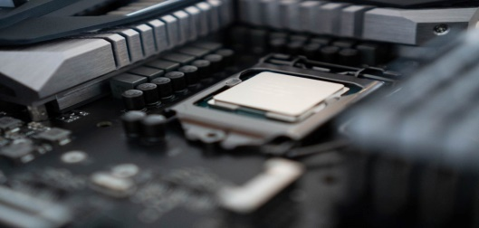

**Portable:**

• Balancing battery capacity and form factor is a challenge for OEMs.

• Balancing battery size and efficiency is crucial.

Efficiency and Low Latency:

• Innovative designs adapt clock and voltage domain based on user application.

• Performance per watt (PPW) is a key issue.

• Frequency and voltage level scaling impact response time.

• CPUs are designed to provide low latency for real-time response.

**Data Center:**

• Data centers are compute-intensive, requiring dedicated hardware for streamlined computation.

• Companies like Google, Facebook, and Amazon are developing silicon that understands data generation and analyzes it on the go.

**Performance and High Throughput:**

• Custom SoC design requires high speed interconnect to remove bottlenecks in data processing.

• Data needs to reside near the computation block, requiring new data prediction methods.

• Electricity/power/energy: Low power hardware with long battery life is crucial in erratic power supply environments.

• Cost: Balancing lowest cost with reliable, functional technology is essential.

• Environment: Products should be designed for durability, including resistance to water, humidity, dust, dirt, and extreme heat.

• Connectivity: The more connected the network, the more valuable it is. Wi-Fi is the main method for connection.

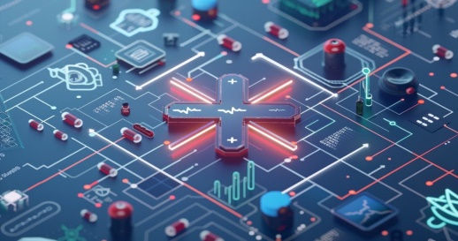• Maintenance and Support: Technology that cannot be locally maintained, supported, and repaired is not sustainable.

**Design Flaws and Inadequate Testing**

* Design flaws and inadequate testing are major issues in hardware development, causing delays and costly redesigns. Research shows that 68% of projects face delays due to these flaws, emphasizing the importance of thorough testing.

**Budget Overruns in the Hardware Product Development Process**

* Budget overruns pose a frequent challenge in hardware product development processes, often stemming from financial missteps such as underestimating project costs during the initial planning phase or ineffective resource management.

Poor Supply Chain Management I

* Inadequate supply chain management can severely disrupt production timelines and inflate costs during the hardware development process. Material procurement delays, transportation issues or supplier shortages can all contribute to project delays, higher production costs and potential revenue losses.

**Incompatibility with Software**

* The next significant challenge in hardware development is ensuring compatibility with hardware vs software. This common issue often arises from inequalities in specifications, interfaces, functionality or communication.

**Regulatory Compliance Issues**

* Regulatory compliance is a critical aspect of hardware development, with standards such as FCC and CE governing hardware design, technical specifications, manufacturing and distribution. These standards ensure products meet safety, electromagnetic compatibility (EMC) and environmental requirements. Non-compliance can lead to project delays and increased costs, affecting over 25% of hardware projects.

**Scalability Constraints**

* Transitioning from prototype to mass production in hardware development presents significant challenges due to scalability constraints. As methods that work well for prototypes may not be suitable for mass production, it is necessary to evaluate and optimize the processes and material sourcing to ensure consistent quality across a larger volume. Nearly 40% of hardware projects experience scalability issues when moving to mass production.

**Lack of Skilled Personnel**

* The skills gap in the hardware development process is a significant challenge, as the demand for skilled personnel often outpaces the available talent pool. According to a survey by Deloitte, 63% of hardware companies report a shortage of skilled workers.

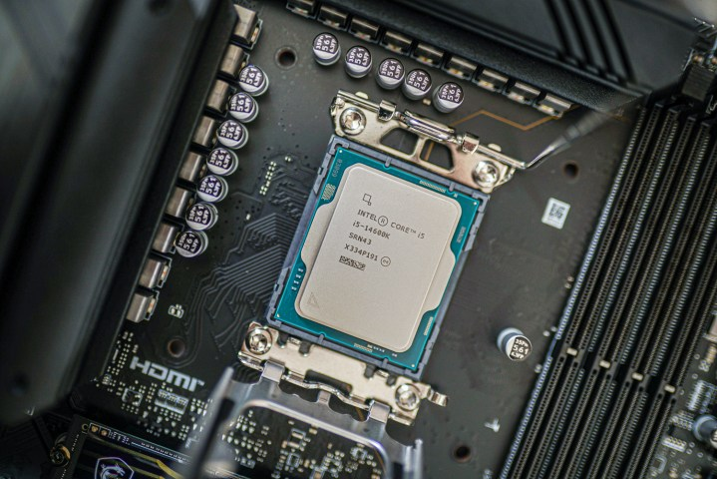***2. What are the latest CPUs?***

***-* Intel Core i5-14600K**

**The best value processor**

**Pros**

* Big improvements in gaming performance
* Same pricing as previous generation
* Works with LGA1700 socket

AI-assisted overclocking on 14900K

**Cons**

* Minor productivity improvements
* Still slower than AMD 3D V-Cache chips
* Still very power hungry

The Core i5-14600K is a more affordable and efficient CPU than Intel's Core i5-13600K. It offers better productivity and gaming performance with additional optimizations and a slight clock speed bump. Despite not raising the price, it is fairly overclockable and is only $30 more expensive than the previous model. However, the last-gen chip offers more performance and could be a better value.

**- AMD Ryzen 7 7800X3D**

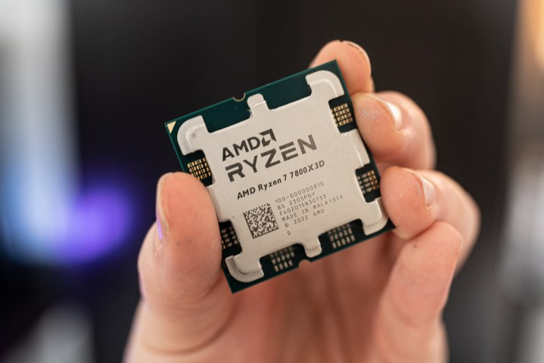 **The best gaming processor**

Pros

* Chart-topping gaming performance
* Great value
* Solid multi-core and productivity performance
* AM5 is getting cheaper

Cons

* Weak single-core performance

The Ryzen 7 7800X3D is AMD's fastest gaming CPU, surpassing Intel's Core i9-13900K and even surpassing the 14900K in most games. It features AMD's 3D V-Cache technology and 104MB L3 cache, a significant upgrade from the Ryzen 7 7700X. With eight cores and 16 threads, the 7800X3D has a lower boost clock speed than the Ryzen 7 7700X, but remains superior in gaming tasks. Its internal testing shows it hits almost the same frames per second as the more expensive Ryzen 9 7950X3D.

- **Intel Core i9-13900K**

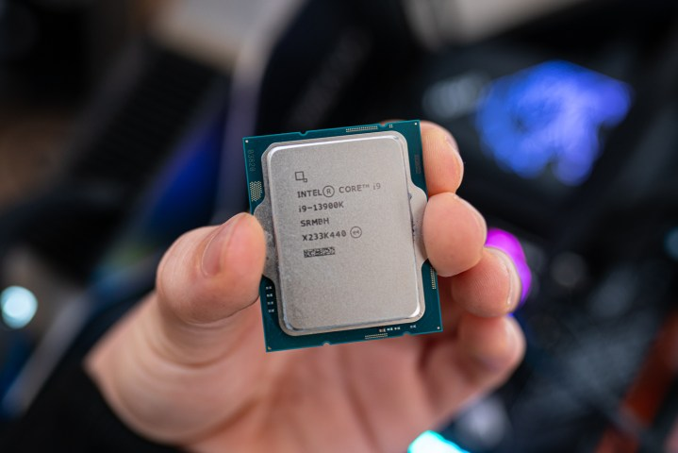 **The best Intel processor**

**Pros**

* Cheaper than AMD competition
* Support for 600-series motherboards and DDR4
* Solid multi-core improvements
* Surprising gen-on-gen improvements

**Cons**

* High power demands
* Small gaming performance gains

Intel's 13900K processor, similar to the 14900K, is cheaper, faster, and uses less power. It combines performance and efficient cores, with eight P-cores and 16 E-cores. It outpaces AMD's best in Cinebench R23 and Cinebench R23 benchmarks.

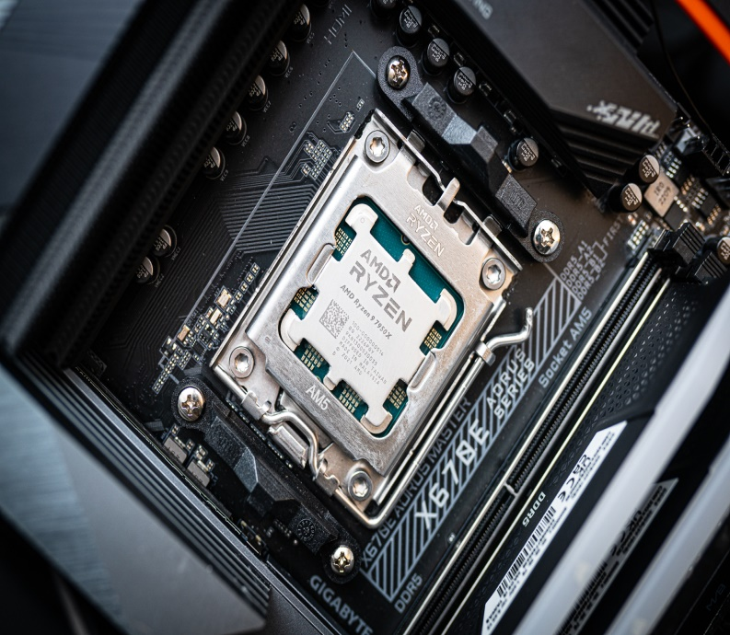

- **AMD Ryzen 9 7950X**

**The best AMD processor**

**Pros**

Off the charts CPU performance

Solid gaming improvements

Integrated graphics work for light games

Works with most AM4 coolers

**Cons**

DDR5 could bloat cost

The Ryzen 9 7950X offers a 31% jump in single-core and 36% improvement in multi-core performance, nearly matching the Core i9-13900K in most tests. It introduces AMD's new AM5 platform, making upgrades more affordable and offering features like Smart Access Memory.

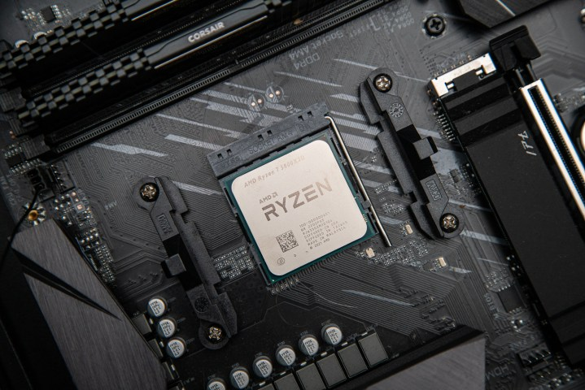 **AMD Ryzen 7 5800X3D - The best last-gen processor for gaming Pros**

The fastest gaming CPU on the market

Solid thermal performance

Works with AM4 motherboards

Inexpensive

Low power requirements

**Cons**

No overclocking

Lackluster general CPU performance

The Ryzen 7 5800X3D is the fastest AM4 gaming processor, boasting an additional 64MB of L3 cache stacked on top. Its 3D V-Cache technology makes it competitive against newer processors from Intel and AMD, but is best suited for gaming tasks.

***3. What are the latest Technological Trends?***

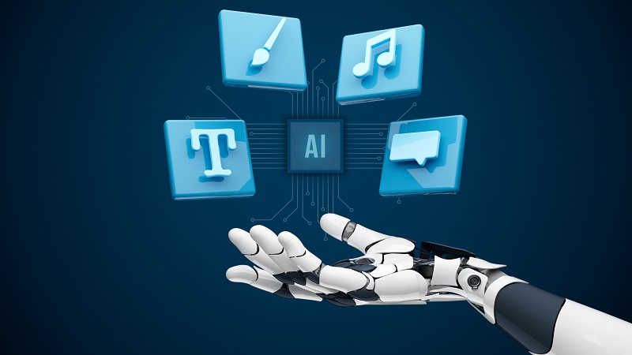**AI-Generated Content**

Artificial intelligence can generate high-quality, creative content, including text, images, videos, and music. This technology uses algorithms like GPT (Generative Pre-trained Transformer) and DALL-E to understand and produce content that resonates with human preferences. The vast applications range from generating articles, creating educational materials, and developing marketing campaigns to composing music and producing realistic visuals. This speeds up content creation and reduces costs, and democratizes access to creative tools, enabling small businesses and individuals to create content at scale.

**5G Expansion**



The fifth generation of mobile networks, 5G, promises significantly faster data download and upload speeds, wider coverage, and more stable connections. The expansion of 5G is facilitating transformative technologies like IoT, augmented reality, and autonomous vehicles by providing the high-speed, low-latency connections they require. This technology is crucial for enabling real-time communications and processing large amounts of data with minimal delay, thereby supporting a new wave of technological innovation.

**Metaverse**



Augmented and Virtual Reality (VR) is revolutionizing the way we live and work by allowing companies to create virtual environments where people can collaborate, conduct training, and close deals in real-time. This technology is gaining traction due to its real-world experience. Nike generated 3100 Ethereum ($8 million) in just a week by selling virtual sneakers. Acceleration has built a metaverse habitat called Nth Floor, replicating their real-world office, allowing employees to work without physically being present. Tech giants like Facebook, Microsoft, Google, and Nvidia are investing heavily in VR, with experts predicting it will add up to $5 trillion to the global economy by 2030. **Quantum Computing**

Quantum computing, a technology that uses quantum bits (qubits) for faster and more complex calculations, is gaining significant investment from tech giants like Google, Amazon Web Services (AWS), and Microsoft. The global quantum computing market is projected to grow by $1765 million by 2025. One promising application of quantum computing is in cryptography, where it can break encryption algorithms and create protocols resistant to external attacks. It also accelerates research in fields like drug discovery, materials science, and artificial intelligence. Quantum computing is a significant trend in information technology, with many more applications expected in the coming years.

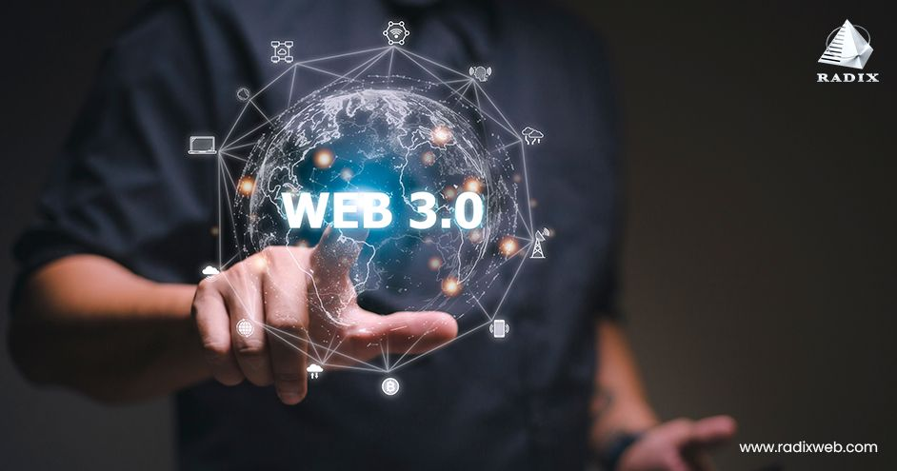**Web 3.0**

Web 3.0 is the next generation of the Internet and web development solutions, a collection of technologies and concepts aimed at creating a more efficient and secure internet. The global Web 2.0 blockchain market is expected to generate $23.3 billion by 2028, with 43% of consumers favoring more regulation. Over $4.5 billion has been raised by 438 Web 3.0 firms. Key technologies driving Web 3.0 include blockchain, artificial intelligence, IoT for embedded development, and augmented reality. As Web 3.0 continues to grow and evolve, it will significantly impact our interactions with the Internet and is a top technology trend in 2024.

**Blockchain**

Blockchain development is a decentralized digital ledger that records transactions securely and transparently, making it ideal for applications requiring trust and security. According to Gartner, the global business value of blockchain is expected to reach $3.1 trillion by 2030. It has also been praised for its potential to increase transparency and accountability in industries like healthcare, where it can securely store and share patient data, reduces costs, and streamline processes across multiple departments. Overall, blockchain is a significant IT trend in recent years.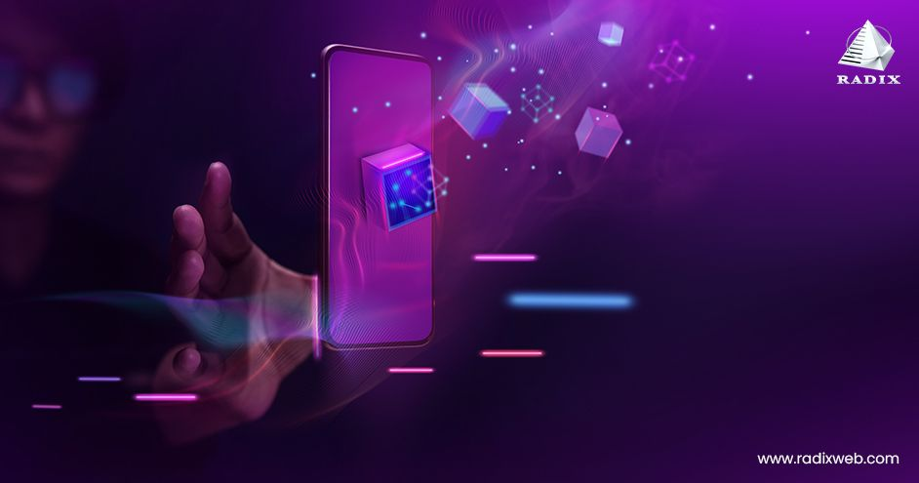

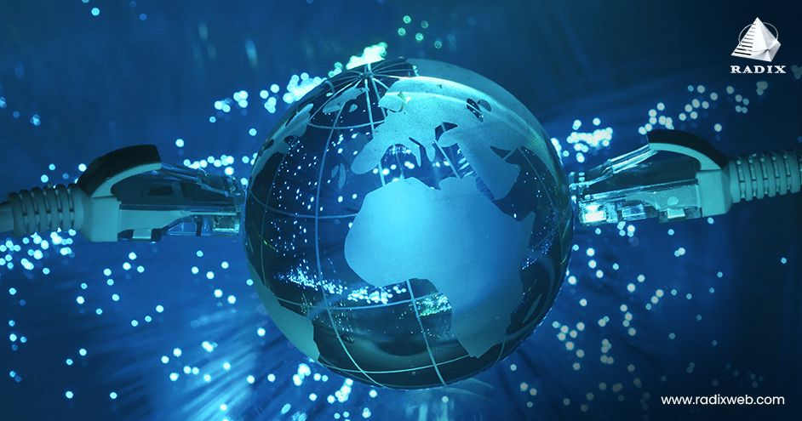**IoT and Hyperconnectivity**

The Internet of Things (IoT) and hyperconnectivity are two emerging technologies that are transforming our lives, work, and interactions. IoT refers to the growing number of physical devices with sensors and software that exchange data over the internet. Hyperconnectivity, on the other hand, refers to the increasing interconnectedness between devices, networks, and people, enabling real-time communication. These technologies can be used in smart homes and cities to monitor energy usage, improve traffic flow, and enhance public safety. Together, they are driving a new era of digital transformation across various industries.

**Sustainable Technology**

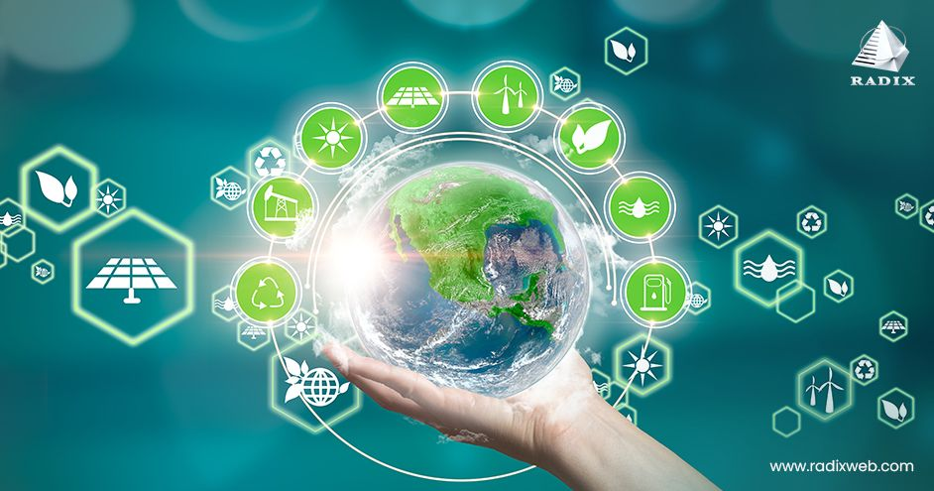

Sustainable technology, or "green tech," is a growing trend in the IT industry, focusing on minimizing environmental impact. It is being developed by individuals, businesses, and governments to reduce their carbon footprint and protect the planet. The primary objective of sustainable technologies is to increase the material and energy efficiency of the IT ecosystem and workflows. Examples include cloud solutions and enterprise greenhouse gas emissions management software. As companies and individuals prioritize sustainability, the demand for sustainable technology is expected to grow. It is a necessary transformation for individuals and organizations to thrive in the future. 50% of CIOs plan to implement performance metrics as part of their IT sustainability strategy.

***4. Use images as your supplementary proof.***

***5. Cite your References below.***

References:

* Bosio, et al. (2020). Exploiting Approximate Computing for Implementing Low Costs Fault Tolerance Mechanisms. <https://typeset.io/papers/exploiting-approximate-computing-for-implementing-low-cost-3bzvh53gmi>
* Patil, et al. (2020). The Challenges And Way Forward For Computer Architecture In Semiconductor Industry. <https://www.chetanpatil.in/the-challenges-and-way-forward-for-computer-architecture-in-semiconductor-industry/>
* Szychulec, (2024). 7 Common Problems in the Hardware Development Process. <https://intechhouse.com/blog/7-common-problems-in-the-hardware-development-process/>
* Roach, et al. (2024). The best processors in 2024: AMD and Intel CPUs duke it out. <https://www.digitaltrends.com/computing/best-processors-any-budget/>
* Wadhwani, (2023). U.S. Federal Judge Exempts AI-Created Content from Copyright. <https://www.spiceworks.com/tech/artificial-intelligence/news/us-copyright-law-ai-generated-content/>
* Sangam, (2021). How Operators Can Rapidly Expand 5G Coverage. <https://www.forbes.com/councils/forbesbusinesscouncil/2021/01/22/how-operators-can-rapidly-expand-5g-coverage/>
* Duggal, (2024). 24 New Technology Trends in 2024: Exploring the Future. <https://www.simplilearn.com/top-technology-trends-and-jobs-article>
* Joshi, (2022). What Is the Metaverse? An Explanation for People Who Don’t Get It.
* <https://www.vice.com/en/article/what-is-the-metaverse-internet-technology-vr/>
* Patadiya, (2024). A Complete List of the Top Technology Trends in 2024.

<https://radixweb.com/blog/top-technology-trends>